|  |
| --- |
|  |
| STEM Explorer Club Student Application  2022-2023 |
| |  |  |  | | --- | --- | --- | | K-5 STEM |  |  | |

***Powered by***

|  |  |  |  |  |  |  |
| --- | --- | --- | --- | --- | --- | --- |
|   ***Powered by***      **2022-2023 STEM Explorer Club**  **Student Application** | | | | | | |
| The Elementary STEM Explorer Program (“Club”) offered through the Pinellas County Schools K-12 STEM Department is a ***free****,* extended learning program for all students in grades K-5. | | | | | | |
| Our vision is to increase STEM opportunities for **ALL** Pinellas County students to prepare them to excel in STEM fields of study, while igniting their curiosity, interest, and excitement in STEM. The STEM Explorer Program is designed to spark student creativity and imagination through innovative hands-on problem-solving tasks, coding, robotics, peer collaboration and leadership while experiencing success utilizing the engineering design process.  To learn more about the K-12 STEM initiatives and the PCS STEM Explorer Program, please visit [www.pcsb.org/STEM](http://www.pcsb.org/STEM) | | | | | | |
| School: | | | | | | |
| Student Information: | | |  | | **One application per student** | |
| Student First Name: Student Last Name: | | | | | | |
| Grade level for the 2022/2023 school year: | | | ☐ K ☐ 1 ☐ 2 | | ☐ 3 ☐ 4 ☐ 5 | |
| Date of Birth: | Gender: ☐ Male ☐ Female | | | Teacher Name: | | |
| Student Ethnicity: ☐ American Indian/Alaska Native ☐ Asian☐/Pacific Islander ☐ Hispanic or Latino  ☐ Black/African American ☐ White/Caucasian American ☐ Decline to State ☐ Other | | | | | | |
| Is your child receiving ESOL (Teaching English for Speakers of Other Languages) services?  ☐ Yes ☐ No | | | | | | |
| Child's Primary Language: | | | Languages Spoken at Home: | | | |
| Does your child have special needs?  ☐ Yes ☐ No  **Specials needs will not exclude a student from**  **the STEM Explorer Club.** | | | Does your child have an IEP/504 on file?  Yes ☐ No | | | |
| **Family Information** | | | | | | |
| **Name:** | | | Relation: | | | |
| Address: | | | | | | |
| Primary Phone Number: | | | Cell Phone Number: | | | |
| E-mail address: | | | | | | |
| **Name:** | | | Relation: | | | |
| Address: | | | | | | |
| Primary Phone Number: | | | Cell Phone Number: | | | |
| E-mail address: | | | | | | |
| How will your child get home from the STEM Explorer Club? ☐ Parent Pick Up ☐ Walker ☐ Bike | | | | | | |
| **Emergency contacts and people authorized to pick up the student from school.** | | | | | | |
| Name: | | Phone Number: | | | | |
| Relation: | | Authorized to Pick Up: ☐ Yes ☐ No | | | | |
| Name: | | Phone Number: | | | | |
| Relation: | | Authorized to Pick Up: ☐ Yes ☐ No | | | | |
| **Medical Information** | | | | | |
| Known allergies: | | | | | |
| Does your child take any medications? ☐ Yes ☐ No *If yes, please list: | | | | | |
| **Privacy Rights** | | | | | |
| I understand that photos and/or videos will be taken during the activities or events of the program. I give permission to the PCS STEM Explorer Program to use photos/videos of my student, family, and myself to be used in educational, promotional, informational or media materials for positive public relations purposes. Please complete the enclosed Media Release. | | | | | |
| **Program Expectations** | | | | | |
| Please read each of the following expectations and provide your signature below in acknowledgement and granting permission for your student to participate in the STEM Explorer Program (“Club”).  Attendance:  Attendance is a vital component to the success of any program. This is especially true of the STEM Explorer Club which consists of weekly building, coding, design challenges and other activities within the engineering design process. Due to an overwhelming interest in the STEM Explorer Program and the rigor of the planned activities, students are expected to attend each club session. If a student receives **three** or more unexcused absences, they may be dismissed from the STEM Explorer Club.    Arrival and Dismissal:  Our STEM Explorer Club facilitators are enthusiastic about STEM and your child; and to honor their commitment to teaching and familial obligations we ask that all students (explorers) are dropped off or picked up promptly at the beginning or conclusion of each STEM Explorer Club session.  Family Involvement (Science Showcase and STEM Expo):  In Spring, students enrolled in the STEM Explorer Program will receive an invitation to attend and present at Pinellas County School’s annual **free** Science Showcase and STEM Expo. The time, date and location for May 2023 event will be announced soon. Additional information will be provided later in the year.  Behavior:  The expectation of each student is to follow all Pinellas County School and STEM Explorer Club facilitators expectations for behavior to ensure a safe, fun, and engaging program.  Parent/Guardian Signature: _________________________________________________ Date: _______________ | | | | | |

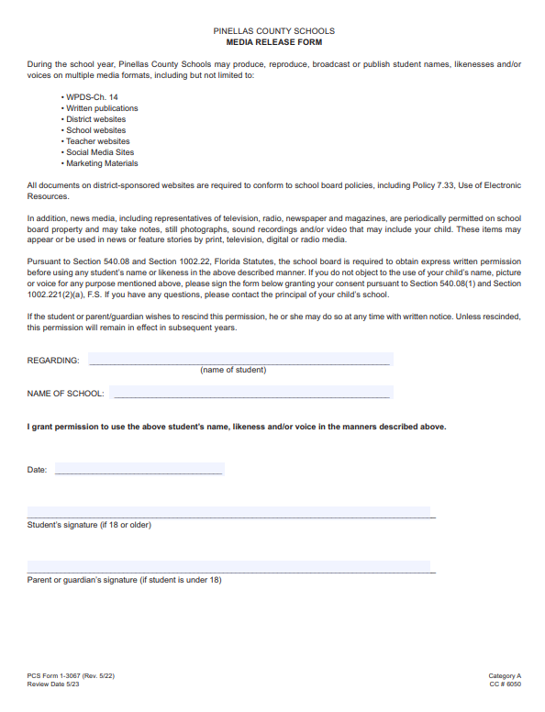S